TEACHER: MR. PHIRI M
1

DESIGN AND TECHNOLOGY DEPARTMENT

LESSON PLAN

SUBJECT: DESIGN AND TECHNOLOGY CLASS: 12 DATE:……/……./20…. DURATION:………….

BOYS:…………………… GIRLS ………………………………………. TOTAL OF PUPILS…
TOPIC: SYSTEM TECHNOLOGY SUBTOPIC: ELECTRONIC

LEARNING OUTCOMES LSBAT
- Define electronic
- State the importance of electronics
- Explain atomic structure of matter
- Identify and Explain electrical and electronics materials

RATIONALE
Knowledge: protons, electronics, neutron, electrical and electronics materials
Skills: Application of electronic materials
Values: Creative thinking when designing electronic circuits, Observation of safety precautions while working

TEACHING AIDS
……………………………………………………………………………………………………………………………………………

PART | LESSON CONTENT | METHO DOLOG Y | LEARNER ACTIVITY
introdu ction | - Recap on the previous lesson | Q/A | Provide answers
Development | ELECTRONIC  - Electronics is the study of the flow of electric current in semiconductors or a vacuum or in gases.  IMPORTANCE OF ELECTRONIC  - Home electrical item (Television set, computer,  - Traffic right  - Cell Phones e.tc  ATOMIC STRUCTURE OF MATTER  - Matter is any substance which has mass and volume  ATOMS  - Atoms are the smallest or fundamental particles of matter that take part in chemical reaction  PARTICLES THAT MADE UP ATOMS  - Protons are positively charged particles found in the nucleus of an atom  - Neutrons are particles found in the nucleus of an atom and do not carry any electrical charge.  - Electrons are negatively charged particles that orbit around the nucleus of an atom.  - Valence Electrons are electrons found in the outer most shell of an atom. They determine the electrical and chemical characteristics of an atom  - Free electrons. These are the electrons that are completely detached from the mother atom and play a role in conducting electric current of a material when the potential difference is applied.  ✓ | Questions And Answers  Demonstr ation  V/E | Taking note of important points  Provide answers
Applicati on | CLASS EXERCISE  - Define electronic  - State the importance of electronics  - Explain three types of electrical and electronic materials | Questions And Answers | Provide answers
Conclu sion | - Recap on the main steps and points | V/E

TEACHER: MR. PHIRI M
2

DESIGN AND TECHNOLOGY DEPARTMENT LESSON PLAN

SUBJECT: DESIGN AND TECHNOLOGY CLASS: 12 DATE:……/……./20…. DURATION:………

BOYS:…………………… GIRLS ………………………………………. TOTAL OF PUPILS…
TOPIC: SYSTEM TECHNOLOGY SUBTOPIC: ELECTRICAL MATERIALS

LEARNING OUTCOMES LSBAT

Identify and Explain electrical and electronics materials
RATIONALE
Knowledge: Electrical and electronics materials

Skills: Application of electronic materials
Values: Creative thinking when designing electronic circuits, Observation of safety precautions while working
TEACHING AIDS
……………………………………………………………………………………………………………………………

PART | LESSON CONTENT | METHO DOLOG Y | LEARNER ACTIVITY
introdu ction | - Recap on the previous lesson | Q/A | Provide answers
Development | ELECTRONIC ELECTRICAL AND ELECTRONICS MATERIALS  - Conductors  - Material which has property to conduct electricity and heat effectively.  E.g. silver, copper and aluminium.  - All conductors have low resistivity ranging between 10-7 to 10-8 Ωm.  - Insulators  - Material which is a very poor conductor of electricity and heat.  - Insulators have resistivity ranging between 10 4 to 10 14 Ωm  - e.g. Plastic, paper, rubber, porcelain, mica, cotton, glass, asbestos, PVC  - Semiconductors  - Materials whose electrical properties lie between those of a conductor and an insulator and are found in group four of the periodic table.  - Examples are silicon and germanium  - Semiconductors have resistivity ranging between 10-3 to 3 x 10-3 Ωm.  - The diagrams below show the atomic structures of silicon and germanium atoms  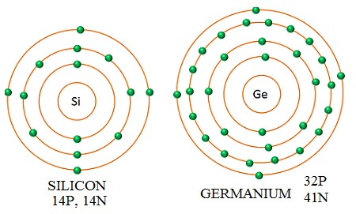 | Questions And Answers  Demonstr ation  V/E | Taking note of important points  Provide answers
Applicati on | CLASS EXERCISE  - Define electronic  - State the importance of electronics  - Explain three types of electrical and electronic materials | Questions And Answers | Provide answers
Conclu sion | - Recap on the main steps and points | V/E

TEACHER: MR. PHIRI M
3

DESIGN AND TECHNOLOGY DEPARTMENT

LESSON PLAN

SUBJECT: DESIGN AND TECHNOLOGY CLASS: 12 DATE:……/……./20…. DURATION:………….

BOYS:…………………… GIRLS ………………………………………. TOTAL OF PUPILS…
TOPIC: SYSTEM TECHNOLOGY SUBTOPIC: SEMICONDUCTORS

LEARNING OUTCOMES LSBAT
- State Properties of semiconductors
- Identify and Explain Types of semiconductors materials

RATIONALE
Knowledge: Extrinsic semiconductors: Intrinsic semiconductors
Skills: Application of electronic materials
Values: Creative thinking when designing electronic circuits, Observation of safety precautions while working
TEACHING AIDS
……………………………………………………………………………………………………………………………………………

PART | LESSON CONTENT | METHO DOLOG Y | LEARNER ACTIVITY
introdu ction | - Recap on the previous lesson | Q/A | Provide answers
Development | SEMICONDUCTORS  Properties of semiconductors  - They have negative temperature coefficient of resistance  - The atoms of semiconductor is covalent bonded  - Semiconductor atoms have four valence electrons each  - At absolute zero (0 k or -273oc) the material behaves like insulator  - At room temperature or above, the material behaves a like conductor  Types of semiconductors materials  - Intrinsic semiconductors:  These are extremely pure semiconductors e.g silicon and germanium elements.  - Extrinsic semiconductors:  These are impure semiconductors doped with impurities so as to increase conductivity.  - The impurities added are known as a dopants or doping agents.  Types of doping agents or dopants  - Pentavalent atoms having five valence electrons e.g. bismuth, arsenic, phosphorus  - Trivalent atoms having three valence electrons e.g. gallium, indium. Al, boron etc  Types of extrinsic semiconductors  - P - Type extrinsic semiconductor.  - Formed by doping a tetravalent element such as, silicon or germanium with a trivalent atom.  - One bond is left incomplete and it produces a hole which is positive in nature  - Trivalent atom + tetravalent element = P - type material..  2. N - Type extrinsic Semiconductor  - Formed by doping a tetravalent element with a pentavalent atom.  - Pentavalent atom + tetravalent element = N - type semiconductor material
Applicati on | CLASS EXERCISE  - State Properties of semiconductors  - Identify and Explain Types of semiconductors materials  - State two types of doping agents or dopants. | Questions And Answers | Provide answers
Conclu sion | - Recap on the main steps and points | V/E
LESSON EVALUATION:

4
TEACHER: MR. PHIRI M

DESIGN AND TECHNOLOGY DEPARTMENT LESSON PLAN

SUBJECT: DESIGN AND TECHNOLOGY CLASS: 12 DATE:……/……./20…. DURATION:………….
BOYS:…………………… GIRLS ………………………………………. TOTAL OF PUPILS… TOPIC: SYSTEM TECHNOLOGY SUBTOPIC: ELECTRONIC BASIC COMPONENTS LEARNING OUTCOMES LSBAT
- Identify and Explain basic electronic components
- Draw conventional symbols used to draw electronic circuit diagrams

RATIONALE
Knowledge: Resistor, Transistor, Opto –coupler, Capacitor, Inductor, Diode, integrated circuit and their symbol
Skills: Identification of basic components, Designing conventional circuits
Values: Application of circuits in artefacts making, Observation of safety precautions when working with PCBs

TEACHING AIDS
PART | LESSON CONTENT | METHO DOLOG Y | LEARNER ACTIVITY
introdu ction | - Recap on the previous lesson | Q/A | Provide answers
Development | ELECTRONIC BASIC COMPONENTS  Resistors  - Electronic component whose function is to restrict or oppose the flow of electrons in a circuit.  - It converts electrical energy into heat energy.  Diodes (rectifiers)  - Diodes allow an electric current to flow through them in only one direction.  - Diodes can be used to change alternating current into direct currents  Types of diodes  - Zener diode , Photodiode , Light emitting diode or LED Varactor diode  Inductor  - Passive electronic component that stores energy in the form of a magnetic field.  Capacitors  - A capacitor is a component used to store charge.  Transistors  - Used in electronics as a device for switching and amplifying signals.  Integrated Circuits  - An integrated circuit (IC), sometimes called a chip or microchip, is a semiconductor wafer on which thousands or millions of tiny resistors, capacitors, and transistors are fabricated.  - An IC can function as an amplifier, oscillator, timer, counter, computer memory, or microprocessor.  Opto-coupler (photo coupler)  - Opto couplers are used for switching high voltage isolated circuit by using light emitted by a diode from another circuit.  SYMBOL FOR ELECTRONIC BASIC COMPONENT  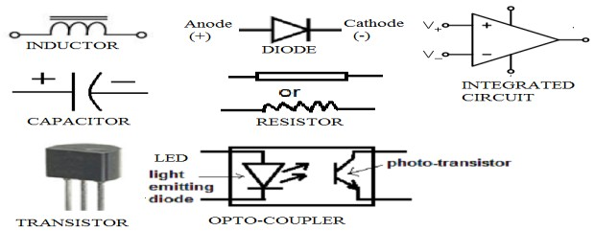 | Questions And Answers  Demonstra tion  V/E | Taking note of important points  Provide answers
Applicatio n | CLASS EXERCISE  - Explain the function of the following electronic components:  - Resistor , Transistor , Opto –coupler , Capacitor, Inductor, Diode  - State four types of diode | Questions And Answers | Provide answers
Conclus ion | - Recap on the main steps and points | V/E
LESSON EVALUATION

5
TEACHER: MR. PHIRI M

DESIGN AND TECHNOLOGY DEPARTMENT
LESSON PLAN

SUBJECT: DESIGN AND TECHNOLOGY CLASS: 12 DATE:……/……./20…. DURATION:………….
BOYS:…………………… GIRLS ………………………………………. TOTAL OF PUPILS… TOPIC: SYSTEM TECHNOLOGY SUBTOPIC: CONSTRUCTION OF DIODE LEARNING OUTCOMES LSBAT
- Explain How A PN-DIODE Is Constructed
- Explain the Forward Biasing P-N Junction Diode

RATIONALE
Knowledge: Construction of PN- diode, Forward Biasing P-N Junction
Skills: Application of forward Biasing
Values: reative thinking when designing electronic circuits, Observation of safety precautions while working

TEACHING AIDS
PART | LESSON CONTENT | METHOD OLOGY | LEARNER ACTIVITY
Introdu ction | - Recap on the previous lesson | Q/A | Provide answers
Development | HOW A PN-DIODE IS CONSTRUCTED  - A p-n junction diode is an electronic component which allows electric current to flow in one direction only.  - Its main function is to convert alternating current (ac) into direct current (dc).  - It is constructed by special alloying together of n - type semiconductor and p –type semiconductor.  - The plane dividing the two regions is known as a junction  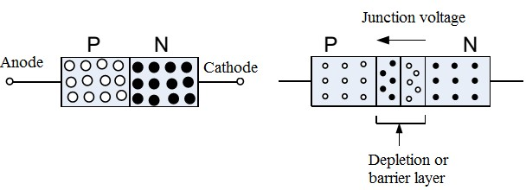  WHEN THE N AND P TYPE MATERIAL ARE BROUGHT TOGETHER THE FOLLOWING HAPPENS  - A thin depletion layer or region is established on both sides of the junction  - Its thickness is about 10-6 m  - A barrier potential or junction potential is developed across the junction  FORWARD BIASING P-N JUNCTION DIODE  - Biasing is the connection of a potential across a PN junction.  - Forward biasing is the connection of a dc voltage across a diode such that it conducts electric current.  - In forward biasing, the positive of the source or battery is connected to the anode (p type material) and the negative of the source is connected to the cathode (n-type material).  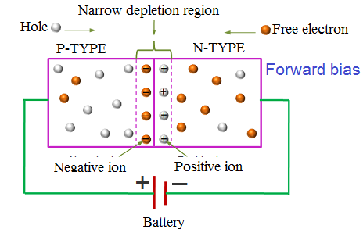  WHEN A DIODE IS FORWARD BIASED THE FOLLOWING HAPPENS AT THE JUNCTION  - Depletion layer decreases.  - Barrier potential decreases.  - Forward resistance decreases.
Application | CLASS EXERCISE  - Define Biasing  - Explain How A PN-DIODE Is Constructed  - Explain the Forward Biasing P-N Junction Diode  - Draw and label the parts of Forward Biasing P-N Junction Diode | Questions And Answers | Provide answers
Conclus ion | - Recap on the main steps and points | V/E
LESSON EVALUATION

TEACHER: MR. PHIRI M

DESIGN AND TECHNOLOGY DEPARTMENT LESSON PLAN

SUBJECT: DESIGN AND TECHNOLOGY CLASS: 12 DATE:……/……./20…. DURATION:………….
6
BOYS:…………………… GIRLS ………………………………………. TOTAL OF PUPILS… TOPIC: SYSTEM TECHNOLOGY SUBTOPIC: REVERSE BIASING A DIODE LEARNING OUTCOMES LSBAT
- Explain Reverse Biasing A Diode

RATIONALE
Knowledge: Reverse Biasing
Skills: Application of Reversing Biasing and
Values: Creative thinking when designing electronic circuits, Observation of safety precautions while working

TEACHING AIDS
……………………………………………………………………………………………………………………………………………

PART | LESSON CONTENT | METHO DOLOG Y | LEARNER ACTIVITY
introdu ction | - Recap on the previous lesson | Q/A | Provide answers
Development | REVERSE BIASING A DIODE  - Reverse biasing of a diode is the connection of a dc voltage across a diode such that it does not conduct electric current.  - In reverse biasing, the dc voltage connected such that the positive of the source is connected to the cathode (n-type material) and the negative of the source is connected to the anode (p-type material.)  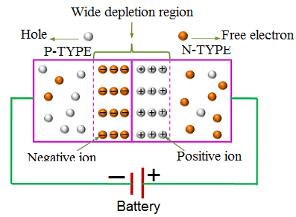  WHEN A DIODE IS REVERSE BIASED THE FOLLOWING HAPPENS AT THE JUNCTION :  - Electrons and holes are repelled further from the junction  - Depletion layer increases.  - Barrier potential increases.  - Reverse resistance increases  - Hence a diode does not conduct when reverse biased | Questions And Answers  Demonstra tion  V/E | Taking note of important points  Provide answers
Applicat ion | CLASS EXERCISE  - Explain the Reverse Biasing A Diode  - Draw and label the parts of the Reverse Biasing A Diode | Questions And Answers | Provide answers
Conclus ion | - Recap on the main steps and points | V/E
LESSON EVALUATION

TEACHER: MR. PHIRI M

DESIGN AND TECHNOLOGY DEPARTMENT

LESSON PLAN

SUBJECT: DESIGN AND TECHNOLOGY CLASS: 12 DATE:……/……./20…. DURATION:………….
7

BOYS:…………………… GIRLS ………………………………………. TOTAL OF PUPILS…
TOPIC: SYSTEM TECHNOLOGY SUBTOPIC: BASIC RECTIFIER CIRCUITS

LEARNING OUTCOMES LSBAT
- Define Rectifiers
- Identify two types of Rectifiers
- Explain the operation of Half- Wave Rectifier

RATIONALE
Knowledge: Rectifier, types of rectifiers (Half- Wave Rectifier and Full Wave Rectifier) and their operations
Skills: Identification of Rectifier.
Values: Application of Rectifiers, Observation of safety precautions

TEACHINGAIDS
……………………………………………………………………………………………………………………………………
PART | LESSON CONTENT | METHO DOLOG Y | LEARNER ACTIVITY
introdu ction | - Recap on the previous lesson | Q/A | Provide answers
Development | BASIC RECTIFIER CIRCUITS  RECTIFIERS  - A rectifier is a circuit which uses one or more diodes to convert AC to DC voltage.  TWO MAJOR TYPES OF SINGLE PHASE RECTIFIER CIRCUITS  - Half- Wave Rectifier  - Full-Wave Rectifier  HALF- WAVE RECTIFIER  Circuit which uses only one diode to convert an AC voltage to pulsating DC voltage  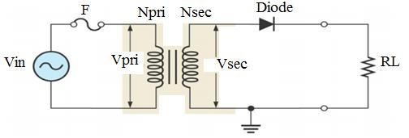  Operation  - During the positive half cycle of the input voltage the polarity of the voltage across the secondary windings forward biases the diode. As a result a current RL flows through the load resistor, RL.  - Thus the pulsating DC voltage appears across the load resistor.  - During the negative half cycle of the input voltage the polarity of the secondary voltage gets reversed. As a result, the diode is reverse biased.  - Practically no current flows through the circuit and almost no voltage is developed across the resistor.  - Therefore in half wave rectification only half cycle is utilised. | Questions And Answers  Demonstr ation  V/E | Taking note of important points  Provide answers
Application | CLASS EXERCISE  - Define Rectifiers  - Identify two types of Rectifiers  - Explain the operation of Half- Wave Rectifier | Questions And Answers | Provide answers
Con clus ion | Recap on the main steps and points | V/E

TEACHER: MR. PHIRI M

DESIGN AND TECHNOLOGY DEPARTMENT

LESSON PLAN

SUBJECT: DESIGN AND TECHNOLOGY CLASS: 12 DATE:……/……./20…. DURATION:………….
7A

BOYS:…………………… GIRLS ………………………………………. TOTAL OF PUPILS…
TOPIC: SYSTEM TECHNOLOGY SUBTOPIC: BASIC RECTIFIER CIRCUITS

LEARNING OUTCOMES LSBAT
- Explain the advantages and disadvantages of Half- Wave Rectifier
- Explain the Peak Inverse Voltage of Half- Wave Rectifier
- Explain the Two Important Terms Used In Rectifier Circuits

RATIONALE
Knowledge: Rectifier, types of rectifiers (Half- Wave Rectifier and Full Wave Rectifier)
Skills: Identification of Rectifier.
Values: Application of Rectifiers, Observation of safety precautions

TEACHINGAIDS
……………………………………………………………………………………………………………………………………
PART | LESSON CONTENT | METHO DOLOG Y | LEARNER ACTIVITY
introdu ction | - Recap on the previous lesson | Q/A | Provide answers
Development | BASIC RECTIFIER CIRCUITS  Advantages of Half Wave Rectifier  - It is economical since only one diode is used  - It is simple in construction as it does not require a centre tapped transformer.  Disadvantage of Half Wave Rectifier  - It has low output because only half positive alternate voltage is rectified  - It has high ripples  - The diode can easily be destroyed since it is the only one rectifying the voltage  Peak Inverse Voltage (PIV) of Half Wave  - PIV is the maximum reverse voltage a diode is able to withstand without it being destroyed. It is given as PIV= VM  - VM = VS/0.707 = VS √2 where = VM= Maximum or peak voltage  VS= Secondary rms voltage  The DC Voltage or Average Voltage of output Load of Half Wave  ➢ VDC = 𝑉𝑀 = 0.31𝑉max  𝜋  Two Important Terms Used In Rectifier Circuits  Peak inverse voltage (PIV)  - It is the maximum reverse voltage which a diode can withstand without destroying its junction.  Ripple Factor  - The output of a rectifier sometimes consists of A.C component which is very much undesirable and it is called Ripple voltage.  - Hence Ripple Factor can be defined as the ratio of A.C component to the D.C component | Questions And Answers  Demonstr ation  V/E | Taking note of important points  Provide answers
Application | CLASS EXERCISE  - Explain the advantages and disadvantages of Half- Wave Rectifier  - Explain the Peak Inverse Voltage of Half- Wave Rectifier | Questions And Answers | Provide answers
Con clus ion | Recap on the main steps and points | V/E

TEACHER: MR. PHIRI M

8

DESIGN AND TECHNOLOGY DEPARTMENT LESSON PLAN

SUBJECT: DESIGN AND TECHNOLOGY CLASS: 12 DATE:……/……./20…. DURATION:………….
BOYS:…………………… GIRLS ………………………………………. TOTAL OF PUPILS… TOPIC: BASIC RECTIFIER CIRCUITS SUBTOPIC: FULL-WAVE RECTIFIER LEARNING OUTCOMES LSBAT
- Define Full-Wave Rectifier
- State two types of Full-Wave Rectifier
- Mention two advantages and one disadvantage of Full-Wave Rectifier
- Explain the operation of Full-Wave Rectifier

RATIONALE
Knowledge: full-wave rectifier (Centre Tapped Full Wave Rectifier and Full-Wave Bridge Rectifiers) Skills: Identification of Centre Tapped Full Wave Rectifier and Full-Wave Bridge Rectifiers Values: Application of Centre Tapped F.W.R and F.W. Rectifiers, Observation of safety precautions

TEACHING AIDS
……………………………………………………………………………………………………………………………………………
PART | LESSON CONTENT | METHODO LOGY | LEARNER ACTIVITY
introdu ction | - Recap on the previous lesson | Q/A | Provide answers
Development | FULL-WAVE RECTIFIER  It is a circuit which uses two or four diodes to convert ac voltage to dc voltage.  TYPES OF THE FULL WAVE RECTIFIERS  Centre Tapped Full Wave Rectifier  - The circuit uses only two diodes (D1 and D2) which are connected to the centre – tapped secondary winding of the transformer.  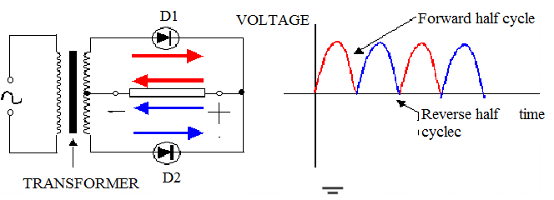  Operation of Centre Tapped Full Wave Rectifier  - When A.C supply is applied at the primary the stepped down or up voltage appears between M and N of the secondary transformer.  - During the positive half cycle G is at zero potential. Hence, being forward biased diode D1 conducts. However diode D2 is reverse biased and does not conduct.  - Therefore current flows through diode D1 and load resistor RL. As a result, positive half cycle of the voltage appears across RL  - During the negative half cycle, when terminal N becomes positive, then diode D2 conducts  (but not D1) and current flows through diode D2 and load resistor Rr..  Advantage Of Centre Tapped F.W.R  - Output D.C voltage and current are twice bigger than that of half wave  - Ripple factor is much less (0.482) than that of H.W.R 1.21  - Efficiency is twice (81.2%) bigger than that of H.W.R (40.6%)  Disadvantages Centre Tapped F.W.R  - The output voltage is half of the secondary voltage  - It is expensive to manufacture a centre –tapped transformer which produce equal voltage  Peak Inverse Voltage (PIV) of a Centre-Tapped Full-Wave Rectifier  - PIV= VS √2 where VS= total Secondary rms voltage  DC Voltage or Average Voltage of Centre-Tapped Full-Wave Rectifier The average or DC voltage across the load is given = VDC = 0.636Vmax | Questions And Answers  Demonstrati on  V/E | Taking note of important points  Provide answers
Applicat ion | CLASS EXERCISE  - Define Full-Wave Rectifier  - State two types of Full-Wave Rectifier  - Mention two advantages and one disadvantage of Full-Wave Rectifier | Questions And Answers | Provide answers
Con clusi on | Recap on the main steps and points | V/E

TEACHER: MR. PHIRI M

8A

DESIGN AND TECHNOLOGY DEPARTMENT LESSON PLAN

SUBJECT: DESIGN AND TECHNOLOGY CLASS: 12 DATE:……/……./20…. DURATION:………….
BOYS:…………………… GIRLS ………………………………………. TOTAL OF PUPILS… TOPIC: BASIC RECTIFIER CIRCUITS SUBTOPIC: FULL-WAVE RECTIFIER LEARNING OUTCOMES LSBAT
- Explain the operation of Full-Wave Bridge Rectifier
- Explain the Peak Inverse Voltage of Full-Wave Bridge Rectifier
- Explain the advantages and disadvantages of Full-Wave Bridge Rectifier

RATIONALE
Knowledge: full-wave rectifier (Centre Tapped Full Wave Rectifier and Full-Wave Bridge Rectifiers) Skills: Identification of Centre Tapped Full Wave Rectifier and Full-Wave Bridge Rectifiers Values: Application of Centre Tapped F.W.R and F.W. Rectifiers, Observation of safety precautions TEACHING AIDS
PART | LESSON CONTENT | METHOD OLOGY | LEARNER ACTIVITY
Introdu ction | - Recap on the previous lesson | Q/A | Provide answers
Development | FULL-WAVE RECTIFIER  Full-Wave Bridge Rectifiers  - It is a rectifier circuit using four individual diodes.  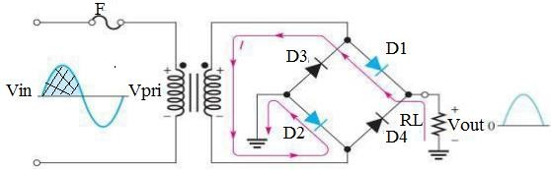  - During the positive half cycle of the input D1 and D2 are forward biased and conduct current.  - D3 and D4 are reverse-biased  - During negative half-cycle of the input D3 and D4 are forward biased and conduct current.  - D1 and D2 are reverse-biased  Operation Of Full-Wave Bridge Rectifier  - During the positive half cycle of secondary voltage, the N of the secondary winding becomes positive and end M negative. This makes D1 and D3 forward biased while D2 and D4 reverse biased. Hence, only diode D1 and D3 conducts.  - During the negative half cycle of secondary voltage, end P becomes negative and end Q positive.  - This makes diode D2 and D4 forward biased and conduct whereas diodes D1 and D3 are reversed biased  Advantage  - The need for centre –tapped transformer is eliminated  - The output power is higher than that of centre tapped type  Disadvantage  - It requires four diodes for its operation.  The peak inverse voltage of full wave bridge rectifier  - PIV = Vm  - Maximum voltage (Vm) of F.W.B.R. Vm= Vs√2  DC Voltage or Average Voltage Of F.W.B.R.  - The average or the dc voltage across the load is given by  ➢ V = 0.636Vm, r =√(𝑉𝑚 )2 − 1  DC  𝑉𝑑𝑐  Two Important Terms Used In Rectifier Circuits  - Peak inverse voltage (PIV). Ripple Factor
Applicati on | CLASS EXERCISE  - Explain the operation of Full-Wave Bridge Rectifier  - Explain the Peak Inverse Voltage of Full-Wave Bridge Rectifier  - State advantages and disadvantages of Full-Wave Bridge Rectifier | Questions And Answers | Provide answers
C  o n | Recap on the main steps and points | V/E

TEACHER: MR. PHIRI M
9

DESIGN AND TECHNOLOGY DEPARTMENT LESSON PLAN

SUBJECT: DESIGN AND TECHNOLOGY CLASS: 12 DATE:……/……./20…. DURATION:………….

BOYS:…………………… GIRLS ………………………………………. TOTAL OF PUPILS…
TOPIC: SYSTEM TECHNOLOGY SUBTOPIC: TRANSISTORS

LEARNING OUTCOMES LSBAT
- Define Transistors
- Describe two types of Transistors.

RATIONALE
Knowledge: Transistors. BJT (PNP, NPN,)
Skills: identification of transistor
Values: Application of Transistor Observation of safety precautions

TEACHING AIDS
PART | LESSON CONTENT | METHOD OLOGY | LEARNER ACTIVITY
Introd uction | - Recap on the previous lesson | Q/A | Provide answers
Development | TRANSISTORS  - Three terminal semiconductors devices that are used for switching and application of signals  TYPES OF TRANSISTORS  - bipolar junction transistor (BJT)  - Field Effect transistor (FET).  BIPOLAR JUNCTION TRANSISTOR (BJT)  - BJT is a current controlled semiconductor device.  - The base current (IB) controls the emitter to collector current (IC)  - BJT are current operated  - Three layer semiconductor device constructed from two junction diodes joined back to back.  - two main types of bipolar junction transistors are NPN and PNP Transistor as shown in the diagram  - The two transistor junctions are the emitter base (E/B) junction and the collector base (C/B) junction  SYMBOLS AND STRUCTURE OF PNP AND NPN TRANSISTOR  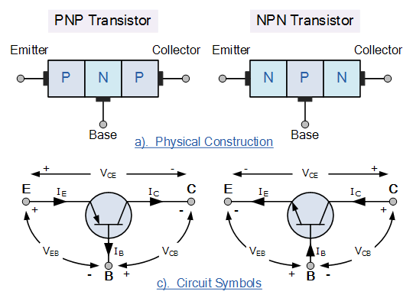  TRANSISTOR TERMINALS  - Emitter:  - This is heavily doped region that emits charge carriers (electrons or holes) into the base region.  - This action constitutes emitter current (IE)  - Base:  - This is the smallest region of transistor sandwiched between the emitter and collector  - Collector  - This collects majority charges coming from the emitter and passing through the base.  - Collector current is about 98% of emitter current
Applicat ion | CLASS EXERCISE  - State three transistor terminals  - Draw the circuit symbol and physical structure of the PNP Transistor  - State two types of transistor | Questions And Answers | Provide answers
Con clusi on | Recap on the main steps and points | V/E

TEACHER: MR. PHIRI M
10
DESIGN AND TECHNOLOGY DEPARTMENT LESSON PLAN

SUBJECT: DESIGN AND TECHNOLOGY CLASS: 12 DATE:……/……./20…. DURATION:………….

BOYS:…………………… GIRLS ………………………………………. TOTAL OF PUPILS…
TOPIC: TRANSISTOR SUBTOPIC: TRANSISTOR CONFIGURATION

LEARNING OUTCOMES LSBAT

Identify and explain transistor configuration
- State three basic functions of transistors
RATIONALE
Knowledge: Transistors. BJT (PNP, NPN,)
Skills: Identification of transistor

Values: Application of Transistor Observation of safety precautions
TEACHING AIDS
PART | LESSON CONTENT | METHOD OLOGY | LEARNER ACTIVITY
Introdu ction | - Recap on the previous lesson | Q/A | Provide answers
Development | TRANSISTOR CONFIGURATION  - Common Base Configuration (CB)  - The Base is common to both the emitter (IE as input) and collector (IC as output).  - Common Emitter Configuration (CE).  - The input signal is applied between the base and emitter, while the output is taken from between the collector and the emitter  - Emitter being common to both collector and the base.  - Common Collector Configuration (CC)  - The collector is made common to both the input and output. The input signal is connected directly to the base, while the output is taken from the emitter load  Diagram For Transistor Configuration  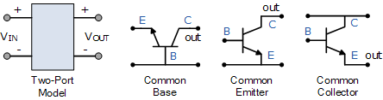  THREE BASIC FUNCTIONS OF A TRANSISTOR ARE :  - used as a switching device in digital electronics  - used as an amplification device in analogue electronics  - used as voltage and current regulators in DC power supplier  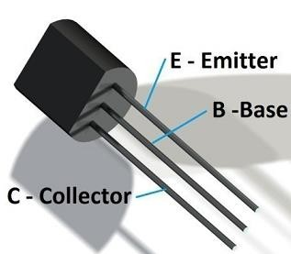
Applicati on | CLASS EXERCISE  - state three basic functions of transistors  - What does the term common collector configuration mean to you?  - State three transistor terminals | Questions And Answers | Provide answers
C  o n | Recap on the main steps and points | V/E
LESSON EVALUATION

TEACHER: MR. PHIRI M

DESIGN AND TECHNOLOGY DEPARTMENT

LESSON PLAN

SUBJECT: DESIGN AND TECHNOLOGY CLASS: 12 DATE:……/……./20…. DURATION:………….
11

BOYS:…………………… GIRLS ………………………………………. TOTAL OF PUPILS…
TOPIC: SYSTEM TECHNOLOGY SUBTOPIC: FILTER CIRCUITS

LEARNING OUTCOMES LSBAT
- Define Filter Circuits
- Identify types of Filter Circuits
- Explain the operation of inductor Filter Circuits

RATIONALE
Knowledge: Filter Circuits, inductor filter Capacitor inductor capacitor filter
Skills: Identification of inductor Filter Circuits
Values: Application of Filter Circuits, Observation of safety precautions

TEACHING AIDS
……………………………………………………………………………………………………………………………………………
PART | LESSON CONTENT | METHO DOLOG Y | LEARNER ACTIVITY
introdu ction | - Recap on the previous lesson | Q/A | Provide answers
Development | FILTER CIRCUITS  - A filter circuit is a circuit which removes pulsations called ripples present in the output voltage supplied by the rectifier.  - Its main function is to remove ripples present in output D.C voltage supplier.  TYPES OF FILTERS  - Inductor Filter  - Capacitor filter  - Inductor Capacitor (Choke Input)  - Capacitor Inductor Capacitor Filter Or Pi Filter  INDUCTOR FILTER  - When the output of the rectifier passes through an inductor, it blocks the ac component and allows only the DC component to reach the load.  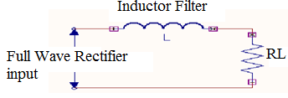  Operation of Inductor Filter  - The function of an inductor filter can be explained in terms of reactance.  - The choke offers high reactance to the ac components but offers almost zero resistance to the desired DC component.  - Thus ripples are removed to a large extent. Usually choke coil resistance Rc, is much smaller than the load Resistance, therefore, almost the entire DC voltage is available across the load resistance RL.  The output DC voltage is given as  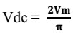  If choke resistance is considered  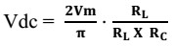  Ripple Voltage  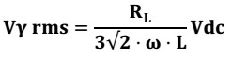 | Questions And Answers  Demonstra tion  V/E | Taking note of important points  Provide answers
Applicat ion | CLASS EXERCISE  - Define Filter Circuits  - Explain the following  - Cut in voltage. b, Cut out voltage | Questions And Answers | Provide answers
Con clus ion | Recap on the main steps and points | V/E

TEACHER: MR. PHIRI M

DESIGN AND TECHNOLOGY DEPARTMENT

LESSON PLAN

SUBJECT: DESIGN AND TECHNOLOGY CLASS: 12 DATE:……/……./20…. DURATION:………….

12

BOYS:…………………… GIRLS ………………………………………. TOTAL OF PUPILS…
TOPIC: FILTER CIRCUITS SUBTOPIC: CAPACITOR FILTER

LEARNING OUTCOMES LSBAT
- Explain Capacitor filter
- Explain the operation of Capacitor Filter

RATIONALE
Knowledge: Capacitor filter, Capacitor inductor capacitor filter
Skills: Identification of Capacitor filter
Values: Application of Filter Circuits, Observation of safety precautions

TEACHING AIDS
……………………………………………………………………………………………………………………………………………
PART | LESSON CONTENT | METHO DOLOG Y | LEARNER ACTIVITY
introdu ction | - Recap on the previous lesson | Q/A | Provide answers
Development | FILTER CIRCUITS  CAPACITOR FILTER  - A capacitor filter connected directly across the load.  - The property of a capacitor is that it allows AC component to conduct through it and blocks DC component.  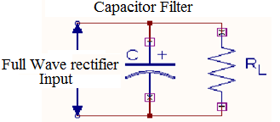  Operation of capacitor filter  - During the positive half cycle, the capacitor charges up to the peak value of the transformer secondary voltage, Vm and will try to maintain this value as the full wave input drops to zero.  - Capacitor will discharge through RL slowly until the transformer secondary voltage again increase to a value greater than the capacitor voltage.  - The diode will conduct when the transformer secondary voltage becomes more than the diode voltage. This is called the cut in voltage.  - The diode stops conducting when the transformer voltage becomes less than the diode voltage or knee voltage. This is called cut out voltage.  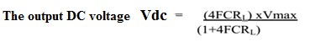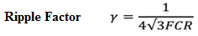  Where F= Frequency, C= capacitance in farads, R=resistance in ohm
Applicat ion | CLASS EXERCISE  - Explain Capacitor filter  - Explain the operation of Capacitor Filter | Questions And Answers | Provide answers
Con clus ion | Recap on the main steps and points | V/E

SUBJECT: DESIGN AND TECHNOLOGY CLASS: 12 DATE:……/……./20…. DURATION:………….

BOYS:…………………… GIRLS ………………………………………. TOTAL OF PUPILS…
TOPIC: FILTER CIRCUITS SUBTOPIC: INDUCTOR CAPACITOR FILTER

LEARNING OUTCOMES LSBAT
- Define Inductor Capacitor Filter
- Explain the operation of Inductor Capacitor Filter

RATIONALE
Knowledge: Inductor capacitor (choke input),
Skills: Identification of Filter Circuits
Values: Application of Filter Circuits, Observation of safety precautions

TEACHING AIDS
PART | LESSON CONTENT | METHO DOLOG Y | LEARNER ACTIVITY
introdu ction | - Recap on the previous lesson | Q/A | Provide answers
Development | INDUCTOR CAPACITOR FILTER (CHOKE INPUT FILTER)  - It is a circuit which consists of an inductor L connected in series with the rectifier output and a Filter capacitor C across the load resistance RL as shown in the fig. below  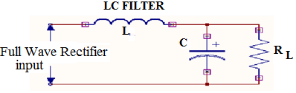  Operation of Inductor Capacitor (Choke Input)  - When the rectifier output is applied to the terminals of the LC filter, the pulsating output of rectifier Contains ac and DC components.  - The choke or an inductor will absorb the AC component but allows the DC component to pass through it.  - At terminal 3, the rectifier output will still have small amount of ac (ripple) which is bypassed by the low reactance of filter capacitor C but prevents the DC component to flow through it, but instead DC component reaches the load Rl..  - The ripple factor is directly proportional to the load resistance RL in the inductor filter and inversely proportional to RL in the capacitor filter.  - Therefore if these two filters are combined as LC filter or L section filter as shown in figure the ripple factor will be independent of RL.  The DC output voltage is given as VDC= 2VM/π If choke resistance is considered  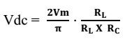  Where Vm= peak secondary voltage RL= Load resistance  RC= Choke resistance  Ripple factor is expressed as 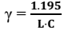  where C = in microfarads, L = in henry for 50Hz supply | Questions And Answers  Demonstr ation  V/E | Taking note of important points  Provide answers
Applicat ion | CLASS EXERCISE  - Explain the Inductor Capacitor Filter  - Explain the operation of the Inductor Capacitor Filter (Choke Input Filter) | Questions And Answers | Provide answers
Con clus ion | Recap on the main steps and points | V/E

SUBJECT: DESIGN AND TECHNOLOGY CLASS: 12 DATE:……/……./20…. DURATION:………….
BOYS:…………………… GIRLS ………………………………………. TOTAL OF PUPILS… TOPIC: SYSTEM TECHNOLOGY SUBTOPIC: FILTER CIRCUITS LEARNING OUTCOMES LSBAT
- Define Capacitor Inductor Capacitor Filter
- Explain the operation of Capacitor Inductor Capacitor Filter

RATIONALE
Knowledge: Capacitor inductor capacitor filter

Skills: Identification of Filter Circuits
Values: Application of Filter Circuits, Observation of safety precautions

TEACHING AIDS
PART | LESSON CONTENT | METHO DOLOG Y | LEARNER ACTIVITY
introdu ction | - Recap on the previous lesson | Q/A | Provide answers
Development | CAPACITOR INDUCTOR CAPACITOR FILTER OR PI FILTER  - It is a filter circuit which consists of a filter capacitor C1 connected across the rectifier output, a choke L in series and another capacitor C2 connected across the load RL as shown in the diagram below.  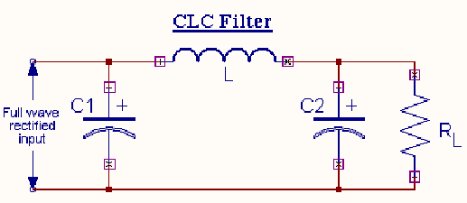  OPERATION OF CLC FILTER  - When the rectifier dc output is fed to the filter circuit. The capacitor C1 offers low reactance to AC component of rectifier output while it offers infinite Reactance to DC.  - Hence capacitor C1 bypasses an appreciable amount of AC component while DC Component continues to choke L.  - The choke L, further offers high opposition (reactance) to the escaped ac but offers almost zero resistance to DC component and flows through it.  - The filter capacitor C2 bypasses (short circuits) the AC component which the choke has failed to Block, therefore, only DC component appears across the load RL.  The DC output voltage is given as VDC= 2VM/π The DC output voltage with choke resistance  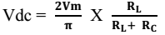 | Questions And Answers  Demonstr ation  V/E | Taking note of important points  Provide answers
Applicati on | CLASS EXERCISE  . Define Capacitor Inductor Capacitor Filter  a. Explain the operation of Capacitor Inductor Capacitor Filter | Questions And Answers | Provide answers
Con clus ion | Recap on the main steps and points | V/E

15
TEACHER: MR. PHIRI M

SESHEKE SECONDARY SCHOOL DESIGN AND TECHNOLOGY DEPARTMENT
LESSON PLAN

SUBJECT: DESIGN AND TECHNOLOGY CLASS: 12 DATE:……/……./20…. DURATION:………….

BOYS:…………………… GIRLS ………………………………………. TOTAL OF PUPILS…
TOPIC: SYSTEM TECHNOLOGY SUBTOPIC: VOLTAGE REGULATOR LEARNING OUTCOMES LSBAT
- Define Voltage Regulator
- Explain the function of Voltage Regulator

RATIONALE
Knowledge: Voltage Regulator, Zener diodes

Skills:
Values: Application of Zener diodes, Observation of safety precautions

TEACHING AIDS
PART | LESSON CONTENT | METHOD OLOGY | LEARNER ACTIVITY
Introd uction | - Recap on the previous lesson | Q/A | Provide answers
Development | VOLTAGE REGULATOR  - It is a circuit or device that maintains terminal voltage of the D.C supply constant even when input voltage to the transformer varies or the load varies.  EXAMPLES VOLTAGE REGULATORS  - Zener diodes and Transistors  The diagram below shows a typical zener diode circuit as a voltage regulator  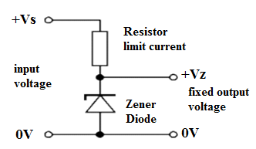  FUNCTION OF A VOLTAGE REGULATOR  - The function of the voltage regulator is to maintain terminal voltage of D.C supply constant regardless of variations in load or input voltage  ZENER AS VOLTAGE REGULATOR  - A Zener diode is always operated in its reverse biased condition.  - A voltage regulator circuit can be designed using a Zener diode to maintain a constant DC output voltage across the load in spite of variations in the input voltage or changes in the load current  - The reverse voltage at which a Zener diode breaks down or conducts is called the Zener Voltage (Vz)  - When biased in the forward direction it behaves just like a normal diode passing the rated current, but when the reverse voltage is applied to it the reserve saturation current remains fairly constant over a wide range of voltage. | Questions And Answers  Demonstrat ion  V/E | Taking note of important points  Provide answers
Application | CLASS EXERCISE  - Define Voltage Regulator  - Explain the function of a voltage regulator | Questions And Answers | Provide answers
Con clusi on | Recap on the main steps and points | V/E

TEACHER: MR. PHIRI M
16

SESHEKE SECONDARY SCHOOL DESIGN AND TECHNOLOGY DEPARTMENT
LESSON PLAN

SUBJECT: DESIGN AND TECHNOLOGY CLASS: 12 DATE:……/……./20…. DURATION:………….

BOYS:…………………… GIRLS ………………………………………. TOTAL OF PUPILS…
TOPIC: SYSTEM TECHNOLOGY SUBTOPIC: ZENER BIASING

LEARNING OUTCOMES LSBAT
- Explain the Zener diodes and their application

RATIONALE
Knowledge: Voltage Regulator, Zener diodes

Skills:
Values: Application of Zener diodes, Observation of safety precautions

TEACHING AIDS
PART | LESSON CONTENT | METHOD OLOGY | LEARNER ACTIVITY
Introd uction | - Recap on the previous lesson | Q/A | Provide answers
Development | VOLTAGE REGULATOR  ZENER BIASING  For proper working of a Zener diode in any circuit, it is essential that it must,  - Be reverse biased  - Have a voltage across it greater than the Zener breakdown voltage  - be in a circuit where the current is less than the maximum Zener current  APPLICATION OF ZENER DIODES (USES)  - as voltage regulators  - for meter protection against damage from accidental application of excess voltage For reshaping a waveform  ZENER DIODE I-V CHARACTERISTICS  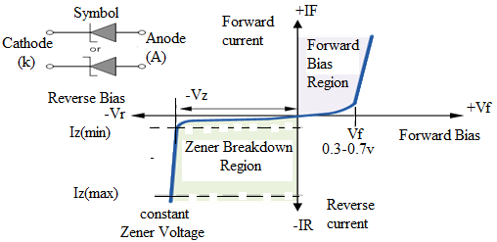  - The function of a regulator is to provide a constant output voltage to a load connected in parallel with it in spite of the ripples in the supply voltage or the variation in the load current and  - The Zener diode will continue to regulate the voltage until the diodes current falls below the minimum IZ(min) value in the reverse breakdown region.
Application | CLASS EXERCISE  - State three application of Zener Diodes  - State three that you need to consider for the Zener diodes to work properly in any circuit | Questions And Answers | Provide answers
Con clusi on | Recap on the main steps and points | V/E

TEACHER: MR. PHIRI M
17

SESHEKE SECONDARY SCHOOL DESIGN AND TECHNOLOGY DEPARTMENT
LESSON PLAN

SUBJECT: DESIGN AND TECHNOLOGY CLASS: 12 DATE:……/……./20…. DURATION:………….

BOYS:…………………… GIRLS ………………………………………. TOTAL OF PUPILS… TOPIC: SYSTEM TECHNOLOGY SUBTOPIC: ZENER DIODE LEARNING OUTCOMES LSBAT
- Explain the Zener diodes and their application

RATIONALE
Knowledge: Voltage Regulator, Zener diodes

Skills:
Values: Application of Zener diodes, Observation of safety precautions

TEACHING AIDS
PART | LESSON CONTENT | METHOD OLOGY | LEARNE R ACTIVIT Y
Introd uction | - Recap on the previous lesson | Q/A | Provide answers
Development | VOLTAGE REGULATOR BASIC ZENER DIODE REGULATOR CIRCUIT  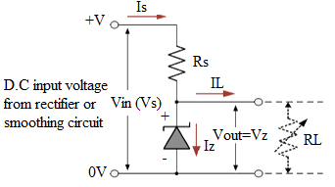  - Where : Iz = Zener Current, Is = Supply Current, IL = Load Current, Rs = Limiting Resistor, Vz = Zener voltage, Vs = supply voltage  ZENER DIODE EXAMPLE  - A 5.0V stabilized power supply is required to be produced from a 12V DC power supply input source. The maximum power rating PZ of the Zener diode is 2W. Using the Zener regulator circuit above calculate:  SOLUTION  - The maximum current flowing through the Zener diode. Watts/voltage = 2w/5v  - The minimum value of the series resistor,  RS = Vs-Vz/Iz = 12-5/400mA = 17.5 ohms (if load resistance RL is included)  - The load current IL if a load resistor of 1kΩ is connected across the Zener diode. IL= Vz/RL= 5v/1000ohms =5mA  - The Zener current IZ at full load.  Lz =IS-IL = 400mA – 5mA= 395mA (if load resistor RL is not included)  ➢
Application | CLASS EXERCISE  - A 10.0V stabilized power supply is required to be produced from a 24 V DC power supply input source. The maximum power rating PZ of the Zener diode is 2W. Using the Zener regulator circuit above calculate  - The maximum current flowing through the Zener diode  - The minimum value of the series resistor, RS  - The load current IL if a load resistor of 2 kΩ is connected across the Zener diode  - The Zener current IZ at full load | Questions And Answers | Provide answers
Con clusi on | Recap on the main steps and points | V/E

18

TEACHER: MR. PHIRI M

DESIGN AND TECHNOLOGY DEPARTMENT

LESSON PLAN

SUBJECT: DESIGN AND TECHNOLOGY CLASS: 12 DATE:……/……./20…. DURATION:………….

BOYS:…………………… GIRLS ………………………………………. TOTAL OF PUPILS…
TOPIC: SYSTEM TECHNOLOGY SUBTOPIC: LOGIC GATES

LEARNING OUTCOMES LSBAT
  - Define digital logic gates
  - Identify and Explain Types of logic gates and their truth table

RATIONALE
Knowledge: NOT, AND, NAND, OR, NOR, EXOR, and EXNOR gates
Skills: Application of electronic materials
Values: Creative thinking when designing electronic circuits,
TEACHING AIDS
PART | LESSON CONTENT | METHO DOLOG Y | LEARNER ACTIVITY
introdu ction | - Recap on the previous lesson | Q/A | Provide answers
Development | DIGITAL LOGIC GATES  - An electronic device that makes logical decisions based on the different combinations of digital signals present on its inputs.  - A logic gate is an elementary building block of a digital circuit  Types of logic gates  - OR gates  - NOR gates  - AND gates  - NAND gates  - NOT gates  - EXOR gates  - EXNOR gates  OR GATE  - Circuit that gives a high output (I) if one or more of its inputs are high. SYMBOL TRUTH TABLE  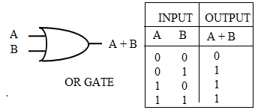  NOR GATES  - The output is low (0) if any of the inputs are high (I).  SYMBOL TRUTH TABLE  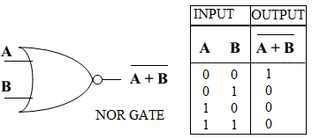
Applica tion | CLASS EXERCISE  - Define digital logic gates  - Identify any three Types of logic gates and their truth table | Questions And Answers | Provide answers
Conclu sion | - Recap on the main steps and points | V/E

18A

TEACHER: MR. PHIRI M

DESIGN AND TECHNOLOGY DEPARTMENT

LESSON PLAN

SUBJECT: DESIGN AND TECHNOLOGY CLASS: 12 DATE:……/……./20…. DURATION:………….

BOYS:…………………… GIRLS ………………………………………. TOTAL OF PUPILS…
TOPIC: SYSTEM TECHNOLOGY SUBTOPIC: LOGIC GATES

LEARNING OUTCOMES LSBAT
  - Explain AND, NOT and NAND gates
  - Make truth tables of AND,NOT and NAND gates

RATIONALE
Knowledge: AND, NAND and NOT, gates
Skills: Application of electronic materials
Values: Creative thinking when designing electronic circuits,

TEACHING AIDS
PART | LESSON CONTENT | METHO DOLOG Y | LEARNER ACTIVITY
introdu ction | - Recap on the previous lesson | Q/A | Provide answers
Development | DIGITAL LOGIC GATES  NOT GATES  - Circuit that produces an inverted version of the input at its output.  SYMBOL TRUTH TABLE  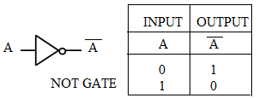  AND GATES  - Circuit that gives a high output (I) only if all its inputs are high.  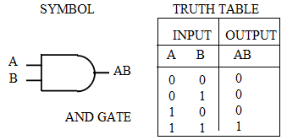  NAND GATE  - The outputs off all NAND gates are high (I) if any of the inputs are low  (0) output (I) if one or more of its inputs are high.  SYMBOL TRUTH TABLE  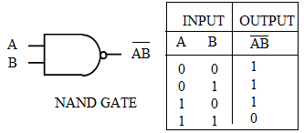
Applicati on | CLASS EXERCISE  - Explain AND and NAND gates  - Make truth tables of AND and NAND gates | Questions And Answers | Provide answers
Conclu sion | - Recap on the main steps and points | V/E

Explain NOT, EXOR, and EXNOR gates
  - Make truth tables of NOT, EXOR, and EXNOR gates
  - State applications of logic gates in daily life.
RATIONALE
Knowledge: EXOR, and EXNOR gates

Skills: Application of electronic materials
Values: Creative thinking when designing electronic circuits,

TEACHING AIDS
PART | LESSON CONTENT | METHOD OLOGY | LEARNER ACTIVITY
introdu ction | - Recap on the previous lesson | Q/A | Provide answers
Development | DIGITAL LOGIC GATES  EXOR GATE  - Circuit which will gives a high output (I) if either, but not both, of its two inputs are high (I).  SYMBOL TRUTH TABLE  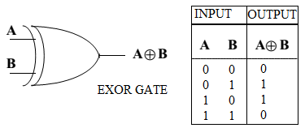  EXNOR GATE  It will give a low (0) output if either, but not both, of its two inputs are high (I).  SYMBOL TRUTH TABLE  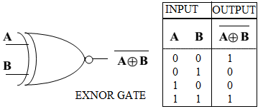  APPLICATION OF LOGIC GATES  - Security Alarm e.g. AND gates  - Doorbell e.g. OR gate  - Temperature detector (e.g. above or below 200c) e.g. NOT gates  - Street lights/ inside car lights  - Seat belt in cars
Applicatio n | CLASS EXERCISE  - Explain NOT, EXOR, and EXNOR gates  - Make truth tables of NOT, EXOR, and EXNOR gates  - State any three applications of logic gates in daily life. | Questions And Answers | Provide answers
Conclus ion | - Recap on the main steps and points | V/E
LESSON EVALUATION:

HOME WORK
TOPIC: DIGITAL LOGIC GATES

CLASS: 12 DATE:
- Consider the circuit shown below which is used to detect failure in either one of the identical circuits operating in parallel
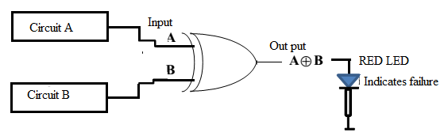
  - What logic gate is symbolised in the circuit?
  - What condition(s) in the input circuits will cause the RED LED to come on?

SOLUTION
- Exclusive-OR, XOR
- Either A or B failing while the other remains working, or A =1, B = 0, or A = 0, B = 1
- A network of cascaded INVERTERS is shown below.
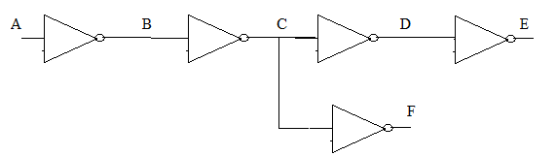

If logic 1 is applied to point A, determine the logic levels at points B through F.
SOLUTION:
➢ A = 1, B = 0, C = 1, D = 0, E = 1, F = 0
3.

